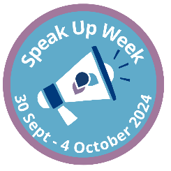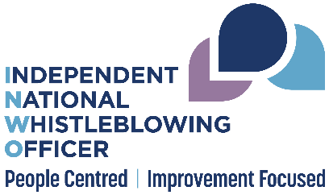

Speak Up Week Social Media Templates

Suggested post 1
We are happy to be supporting #SpeakUpWeek 2024! It’s an opportunity for @NHSScotland organisations to have open conversations about how to grow a healthy and sustainable speak up culture. We want to be part of that conversation! #SpeakingUp #EnablingSpeakingUp @SPSO_Ombudsman

Suggested post 2
#SpeakUpWeek is a chance for us to make sure that the arrangements for raising concerns within our workplace are well known and accessible to all staff. We want to highlight the importance of enabling speaking up. Looking forward to the week ahead! @SPSO_Ombudsman

Suggested post 3
We are looking forward to #SpeakUpWeek and sharing all the activities we are getting up to. We are taking part to celebrate speaking up and highlighting the importance of this week’s theme of #EnablingSpeakingUp @SPSO_Ombudsman

Suggested graphic (insert organisation logo)