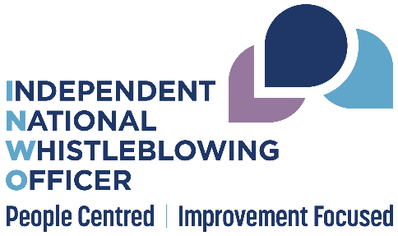

Quick reference guide for managers receiving concerns

This guide provides headline information and links for managers to use when they receive concerns and are uncertain about how to handle them.

Is it a whistleblowing concern?
- Definition of whistleblowing in the Standards (remember: someone providing a service for NHS, speaking up about an NHS service, in the public interest, when there is a risk of harm or wrongdoing). This is in contrast to a grievance for personal employment issues.
- The person raising a concern has to opt into using the National Whistleblowing Standards. (See INWO website for alternatives to using the Standards).
- The person must be willing to have their name recorded confidentially to use the Standards (see website for anonymous and unnamed concerns).
- Benefits of the whistleblowing process include confidentiality, protection from detriment, access to independent external review by INWO.

Should I respond or should I refer it onto someone else?
- People can raise concerns in a number of different ways.
- Boards have different approaches to handling concerns. Seek advice from the whistleblowing co-ordinator/lead if you are unsure whether you should deal with the concern yourself.
- Concerns can be accepted under the Standards at stage 1 for issues that do not need investigation, or stage 2 for complex concerns or issues unresolved at stage 1.
- Response times: 5 working days for stage 1 concerns
20 working days for stage 2 concerns
(See webpages for guidance on extensions).
- Stage 2 concerns should be referred to the whistleblowing co-ordinator/lead.
- Concerns should be recorded. Ask your co-ordinator about the local recording systems and procedures.

How do I support the person who raised the concern?
- Protect their identity. Think about where you meet and the privacy of that location, and how any calendar invitation is worded.
- Be open and appreciative. Thank the person for speaking up, reassure them they have done the right thing and that their details will be kept confidential.
- Make any reasonable adjustments for access to materials and location and think about whether the person may be vulnerable (the SPSO’s guidance on vulnerability may provide a useful approach).
- Ask what support they need. Other organisations can help. Consider support in its widest possible sense (there is more information on providing support).
- Know what local options are available e.g. confidential contacts (more information under ‘the role of NHS staff’), local union reps, chaplaincy, minority support groups.
- Support should be ongoing. Check in with the whistleblower during the process and afterwards.
- If the whistleblower experiences detriment at any point in the process, take advice from the whistleblowing co-ordinator/lead and HR. Ensure appropriate action is taken to protect the person. (see employer's duty of care).
- Be aware of potential barriers to taking concern forward. Some staff may feel particularly vulnerable if they speak up (see who can raise a concern for examples).

Who will know (or need to know) the whistleblower’s identity?
- The whistleblower’s identity must be kept confidential and not routinely shared.
- Talk to them about who will need to know their identity and why.
- In some circumstances it may be difficult to ensure confidentiality during an investigation, due to existing circumstances/ team size/ concerns already raised; this should be explored with the whistleblower.
- Know your local whistleblowing process and tell the whistleblower who is involved and will be aware of their details.
- If they have not already made contact with a confidential contact, ensure they have access for ongoing support if needed.

What do I do if I’m not clear whether something is Human Resources (HR) or whistleblowing?
- Whistleblowing has a public interest. HR concerns are usually related to personal relationships in the work place (more information on HR vs whistleblowing).
- If you are unsure contact your local whistleblowing lead for advice or the Standards team at SPSO and signpost the person to HR and the INWO as appropriate.
- Remember that the person must be allowed to submit a whistleblowing concern if they wish to. If there is uncertainty about whether the issue meets the definition of whistleblowing or HR, the board should accept the concern and determine whether it is HR or whistleblowing. It should not refuse to log and accept it. If it is an HR matter they should inform the whistleblower in writing and signpost to HR and the INWO as appropriate.
- HR staff should also be able to signpost to whistleblowing.
- The person must also be informed in writing and signposted to the INWO if their concern does not meet the definition of whistleblowing in the Standards and is not an HR issue.

During an investigation
- If you are aware that an investigation is ongoing in your area, be supportive of everyone involved in the whistleblowing process including witnesses or people accused of wrong doing.
- If you become aware that one of your staff is struggling or experiencing detriment due to their involvement with a whistleblowing investigation, offer support and consult the whistleblowing lead for advice.
- Take special care not to inadvertently reveal information to others either about the whistleblower (directly or indirectly) or the concern.
[Your organisation] whistleblowing contact and logging information

Confidential contact [or equivalent] Whistleblowing lead
[Name] [Name]
[Contact details] [Contact details]

Process for logging whistleblowing concerns:
[Your organisation’s process for logging concerns and who has access to this]

